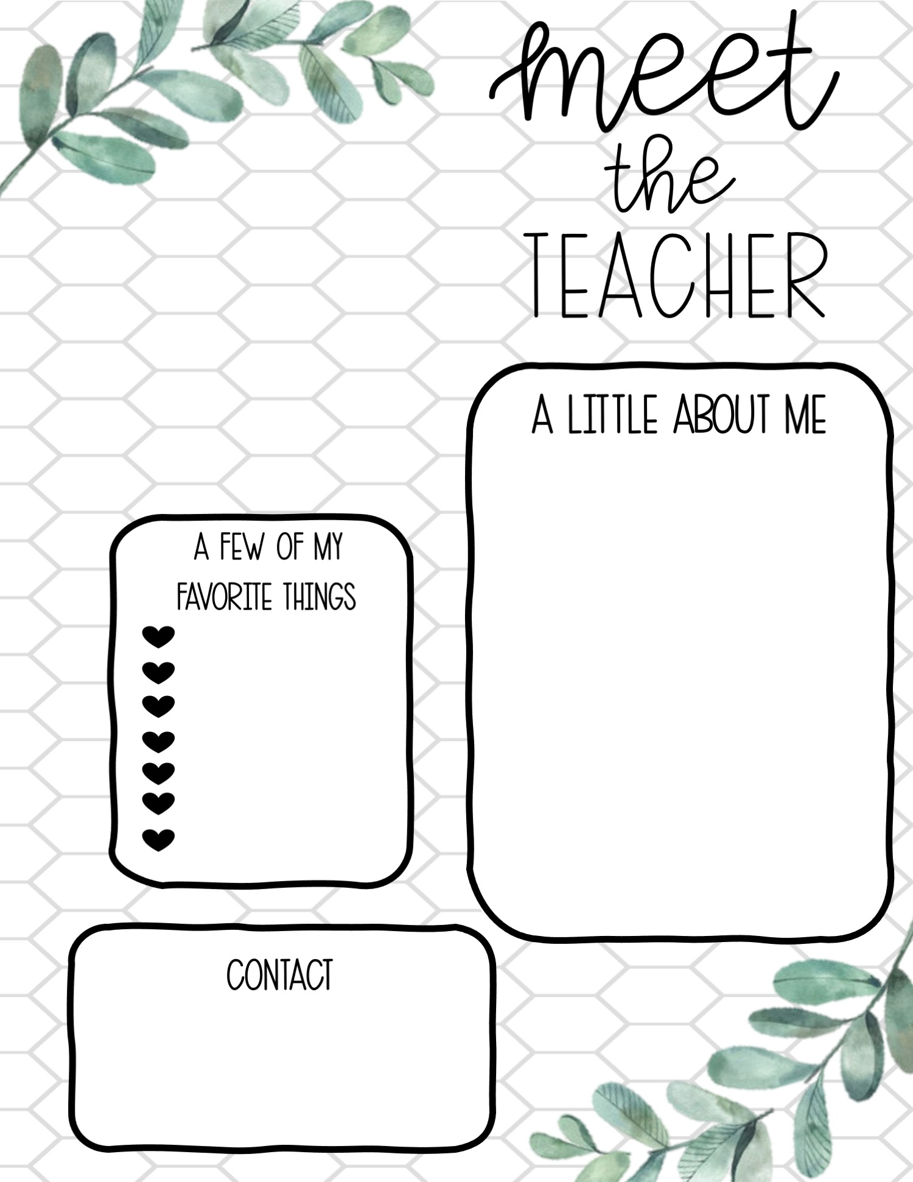
Please feel free to speak to me in person, message me on class dojo or even email at eflowers@forestglade.notts.sch.uk.
The colour purple
Chocolate & pizza
Reading a book
Listening to music
Going swimming
Relaxing at the beach
Making memories with my family
Hello everyone my name is Miss Flowers and I am going to be your class teacher for next year! I have been working at Forest Glade Primary School for over 15 years. I have worked in Year One, Reception and Nursery throughout my time at Forest Glade. My favourite thing to do in school is read stories and sing lots of songs. When I am not at school, you can find me with my family at home (they are such an important part of my life!). I live with Mr Flowers and have two children; Samuel (aged 12 and in year 7 and Caitlin aged 10 in Year 5), which you may hear about or even see in videos. We love going on holiday and making memories together. I love teaching and having fun in the classroom, and I can’t wait to get to know you in September. We are going to have a great year together! Miss E Flowers

Hello everyone, I am Miss Flowers and I am your new Nursery teacher. I have been working at Forest Glade Nursery for over 10 years. I have worked in Year One, Reception and Nursery throughout my time at Forest Glade. I am a Foundation Stage Teacher and set up the nursery three years ago which has been extremely successful. When I am not a school you can find me with my family at home (they are such an important part of my life!). I have two children; Samuel (aged 9 and in year 5 and Caitlin aged 7 in Year 3) which you may hear about or even see in videos.We

