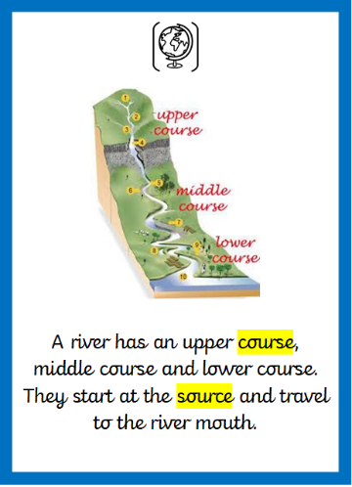 | 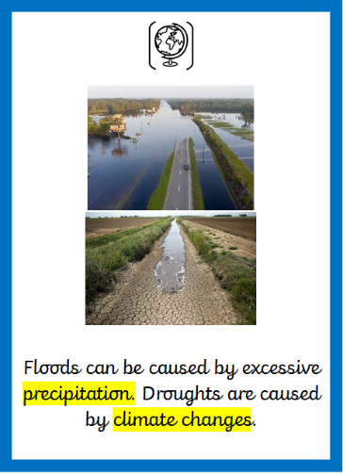 | 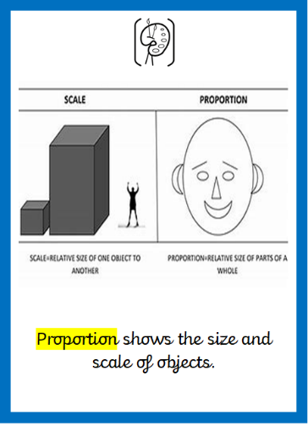 | 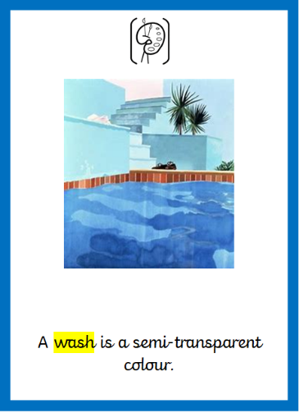 | 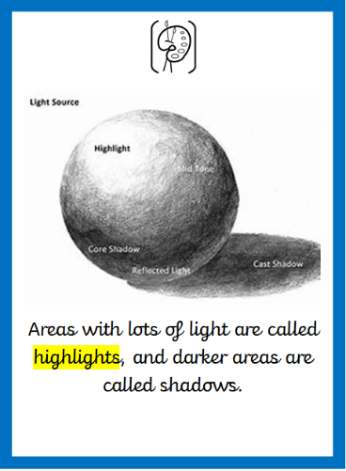
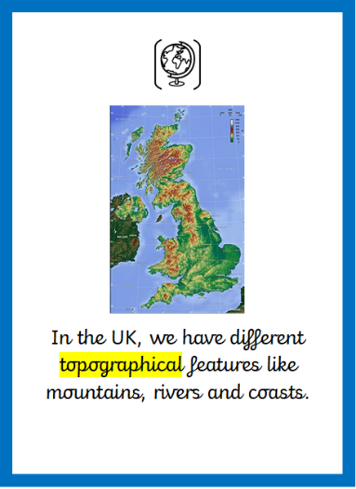
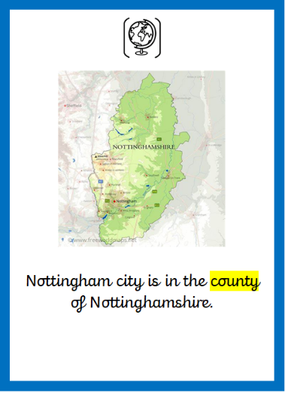
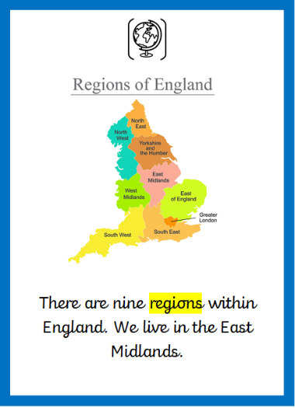
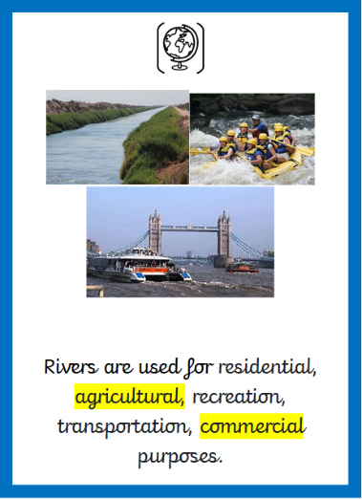
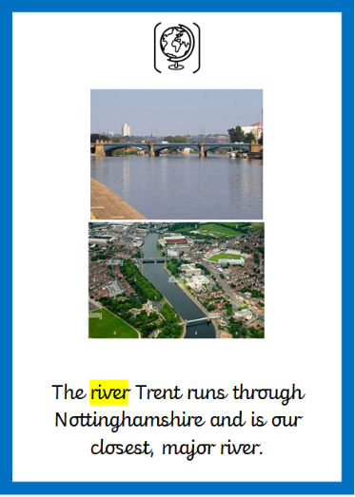
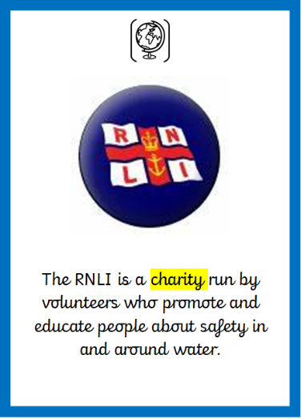
Year 4 Autumn Term Knowledge Organiser

Year 4 Autumn Term Key Vocabulary
charity | An organisation set up to provide help and raise money for those in need.
region | An area, especially part of a country or the world having definable characteristics but not always fixed boundaries.
county | An area of land with its own administration.
topographical | Relating to the arrangement or accurate representation of the physical features of an area.
river | A large natural stream of water flowing in a channel to the sea, a lake, or another river.
agriculture | The science or practice of farming, including cultivation of the soil for the growing of crops and the rearing of animals to provide food, wool, and other products.
commercial | Making or intended to make a profit.
course | The route or direction followed by a ship, aircraft, road, or river.
source | The place something comes from or starts at, or the cause of something.
precipitation | Rain, snow, sleet, or hail that falls to or condenses on the ground.
proportion | The relationship of one thing to another in terms of quantity, size, or number.
wash | Brush with a thin coat of dilute paint or ink.
highlights | A bright or reflective area in a painting, picture, or design.

Do we always appreciate what we have?

