
Home Learning Menu
Autumn – Do we always appreciate what we have?
Explore
We would love for you to engage with our enquiry at home. In the table below there are lots of optional activities to pick and choose from this term. Once you have completed an activity, please upload it using a photo/video on your Class Dojo portfolio. Your home learning will be rewarded with Dojo points as well!
Find Nottinghamshire on Google images.  What else is near Nottingham?  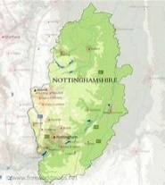 | Go on a nature walk.  Capture photos of:  A river/lake  A tree  An animal  A flower  Recreate these photos using watercolour! | Create a water safety poster including dos and don’ts while in water!   | Research a country that doesn’t have easy access to water.  What do you notice about that country? What could we do to help them?
Investigate how you can turn muddy water into clean water.  Have a go yourself! How clean can you get the water? 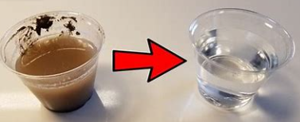 | Create a sculpture out of cardboard, Lego or any material to show how a river is formed from the source to the river mouth.  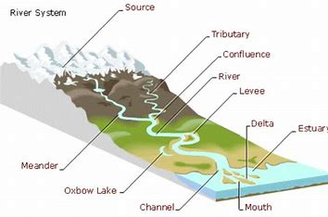 | Google the world’s largest rivers in the world.  What are their names?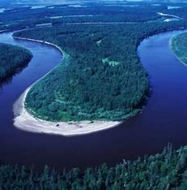 | Look around your house.  What can you see that is a solid, liquid or a gas? 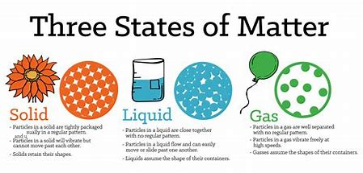
Create a presentation about water pollution and find a solution to help it!  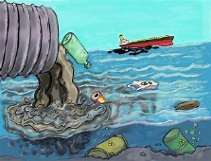 | Create a fact file about the River Trent!  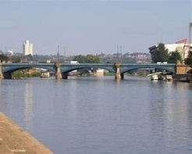 | Take a walk around Sutton-In-Ashfield! What can you see: Kingsmill reservoir, Saint Mary’s church, Llamas Leisure Centre, McDonalds?  Plot these on a map! | Find photos of different animals you would find in the East Midlands. Create a chart for the different animal classes (mammals, birds, reptiles, amphibians or insects).  What do you notice?
Investigate similarities and differences between plants and animals.  Create a Venn diagram to show your findings! | Create a river acrostic poem!  R  I  V  E  R | Take a trip to Nottingham or a Google Map tour and make note of the landmarks you can see.  Where are the lions?  Where is Goose Fair held?  Where is the River Trent?  Where is the castle? | Follow a tutorial on how to create your own instrument and play a song on it!  

